Project Design Phase-II
Technology Stack (Architecture & Stack)

Date | 30 September 2026
Team ID | SN-TRANSFORM-01
Project Name | Import Data using Transform Maps (Spreadsheet)
Maximum Marks | 4 Marks

Technical Architecture:
The architecture below shows how the spreadsheet, ServiceNow staging and target tables, Transform Map logic, history, reports and dashboard work together.
ServiceNow Employee Import Architecture
Project reference: Import Data using Transform Maps (Spreadsheet)
Guidelines:
Include all the processes (As an application logic / Technology Block)
Provide infrastructural demarcation (Local / Cloud)
Indicate external interfaces (third party API’s etc.)
Indicate Data Storage components / services
Indicate interface to machine learning models (if applicable)
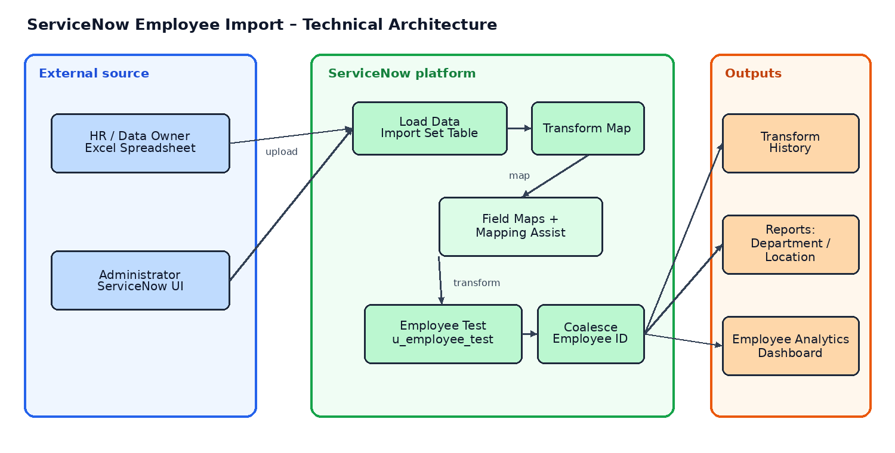

Table-1 : Components & Technologies:
S.No | Component | Description | Technology
1 | Source Interface | Spreadsheet supplied by HR / data owner; header row and sample employee records. | Excel / Google Sheets export
2 | Import Set Table | Staging area that receives the uploaded rows before transformation. | ServiceNow Import Set: Employee Import
3 | Transform Map | Controls source-to-target mapping and executes the employee data transformation. | Sample Spreadsheet Import
4 | Field Mapping | Maps Employee ID, Name, Email, Department and Location between tables. | Auto Map + Mapping Assist
5 | Target Database | Stores validated employee records in the custom target table. | ServiceNow: Employee Test / u_employee_test
6 | Duplicate Control | Matches existing records so repeated IDs update rather than insert duplicates. | Coalesce = true on Employee ID
7 | Audit / History | Records transform state and inserted, updated, ignored and error outcomes. | Transform History
8 | Reporting | Visualizes department distribution, location distribution and employee records. | ServiceNow Reports: Pie, Bar, List
9 | Dashboard | Combines the three reports for HR and administrator monitoring. | Employee Analytics Dashboard
10 | Access Control | Controls who can load data, configure maps, view records and manage reports. | ServiceNow roles and ACLs
11 | Infrastructure | Managed application and database services host the import workflow. | ServiceNow platform / SaaS

Table-2: Application Characteristics:
S.No | Characteristics | Description | Technology
1 | Open-source frameworks | No custom application framework is required; the deliverable uses standard ServiceNow configuration. | ServiceNow platform configuration
2 | Security implementations | Use role-based access, ACLs, controlled imports and Employee ID as the logical match key. | ServiceNow ACLs, roles, Coalesce
3 | Scalable architecture | Staging separates file intake from target storage and supports larger recurring imports. | Import Sets + Transform Maps
4 | Availability | Reports and dashboard are centrally available to authorized ServiceNow users. | ServiceNow application services
5 | Performance | Batch load and transform reduce manual entry; mapping and validation keep data processing focused. | Import Set batch processing

References:
ServiceNow project brief: Import Data using Transform Maps (Spreadsheet)
ServiceNow Import Sets and Transform Maps configuration workflow
ServiceNow reporting and dashboard configuration
Custom table u_employee_test and Import Set u_employee_import
Design principle: stage, transform, validate, report

